TCP/IP Networking Model
TCP/IP model defines and references a large collection of protocols that allow computers to communicate. TCP/IP model creates a set of rules that allow the computer to be connected to use the network. Every computer in the world uses the TCP/IP model. The OS on the PC implements parts of the TCP/IP model for browsers and app to work.
- Networking Model refers to a comprehensive set of documents that will define everything that should happen within a computer network
- Protocols are a logical set of rules that devices must follow to communicate within the network.
- TCP/IP Model avoids repeating work defined by other Standards. TCP/IP refers to the standards or protocols created by those groups.
  - For example, the Institute of Electrical and Electronic Engineers (IEEE) defines Ethernet LANs; the TCP/IP model does not define Ethernet in RFCs, but refers to IEEE Ethernet as an option.
  - Protocols defined in TCP/IP use documents known as Request for Comments (RFC).

TCP/IP Model Layers | Protocols
L5-L7; Application | HTTP, POP3, SMTP
L4; Transport | TCP,UDP
L3; Network | IP, ICMP
L2; Data Link | Ethernet, 802.11 (Wi-Fi)
L1; Physical
Figure1: TCP/IP Model & Protocols
- The TCP/IP model breaks each function into small number or categories called layers. Each layer will provide a service to the layer above it. Each layer also includes protocols and standards that relate to that category of functions

TCP/IP Application Layer – Layer 5
This layer focuses on the applications that need to send and receive data. Basically, it provides an interface or service between software running on the PC and the network itself. Layer 5 doesn’t define the application, instead defines the services that application needs.
- Most popular Application Layer protocol: HTTP.
It can pull content of a web page from a web server as shown on Figure 2.
- Hypertext Transport Protocol (HTTP) will allow the PC to send GET Requests, files, for a web page. The server will return the content being requested through an HTTP Reply. This is the basic logic for a web browser to display content for the user.
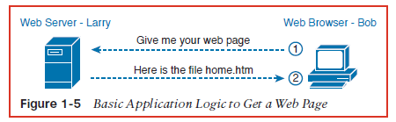
Figure 2: Basic Application Logic to Receive Web Page
  - Explanation of Figure 2
- Bob opens his browser. His browser has been configured to automatically ask for web server Larry’s default web page, or home page. Bob sends a message with an HTTP header that includes a request to “get” a file; HTTP GET Request. If no filename is included in the header, the server will assume Bob is requesting the home page.
- Bob’s initial request actually asks Larry to send his home page back to Bob. Larry’s web server software has been configured to know that the default web page is contained in a file called home.htm. Larry’s web server Reply’s with their own HTTP header that includes a return code of 200 (“Ok”); HTTP Reply. This second message will include the initial response of the requested file.
- Bob receives the file from Larry’s web server and is now able to display the contents of the file in Bob’s web browser. Larry’s web server will continue to send messages to Bob’s PC but without the header. If a header was sent every time, then this would waste space that list the same information. The additional messages simply omit the header.

TCP/IP Transport Layer – Layer 4
Layer 4 will provide services to the layer above it, the Application Layer. The service Layer 4 offers to the layer above it, Layer 5, is provided by TCP’s error recovery. OSI PDU: Segment
- Most common TCP/IP Transport Layer protocol: TCP and UDP
- Transmission Control Protocol (TCP) is a communication standard that will provide reliable data transmission through error checking. This protocol uses the concept of Acknowledgements (Ack.) when error checking. TCP Is able to reliably send or receive data to recover.
- User Datagram Protocol (UDP) is a simple protocol that exchanges datagrams without using acknowledgements or can guarantee the delivery of data; this can be unreliable to L5. UDP is mainly used for Live-Real time connections (Voice data)
  - TCP Error Recovery Basics
In order to avoid accepting larger blocks of data being transmitted, Layer 4 divides this data into smaller blocks when going across the network. Segmenting the packets of data would be easier to manage and transport for successful data transmission.
When transmitting data, these segmented packets can often be lost and can have the user end up with a corrupted file as the outcome.
TCP/IP creators have included an error-recovery mechanism in order to guarantee delivery of data across the network. The L4 protocol of TCP would be able to use the concepts of Acknowledgements to allow devices to resend or resolve the corrupted or missing data.
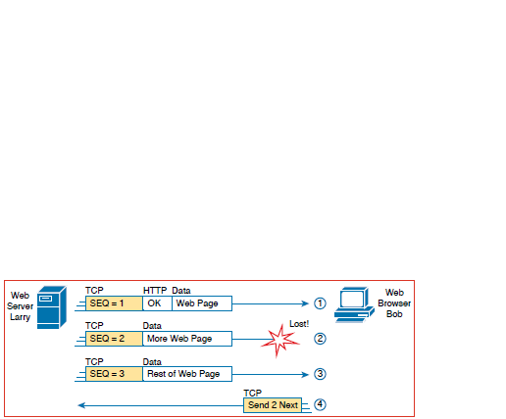
Figure 3: TCP Error-Recovery Services as Provided to HTTP
  - Explanation of Figure 3
- Larry’s server is sending HTTP Replies to Bob’s browser using three separate messages. An HTTP header is attached to the first message followed by a TCP header. Each TCP header will provide a sequence number, SEQ 1, 2, and 3, from Larry’s server when each message is sent to Bob’s browser.
- The network experienced a problem and failed to deliver SEQ 2 TCP’s message; this message is known as a segment.
- Bob’s browser Ack. SEQ 1 & 3 but didn’t Ack. SEQ 2 since it was lost in transmission.
- Bob’s browser TCP logic causes Bob to send a TCP Segment back to Larry’s server. Bob will ask Larry to send the SEQ 2 segment to recover the missing data.

Same-Layer Interaction and Adjacent Layer Interaction
Figure 3 demonstrates the function of adjacent-layer interaction and same-layer interaction.
- Adjacent-Layer Interaction refers to the concept of how an Adjacent Layer, in a networking model, on the same computer, work together to provide services to one another.
  - The higher-layer, L5’s HTTP, wants to use the lower-layer, L4’s TCP error-recovery, to provide services.
- Same-Layer Interaction refers to the concept of two computers using the same particular layer to communicate with one another across the network.
  - Larry used TCP to create sequence numbers on the segments while Bob used TCP to receive, react, and request missing TCP segments.
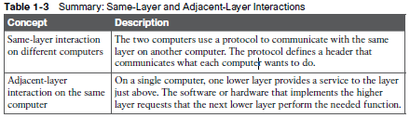

  - Comparing TCP and UDP Headers
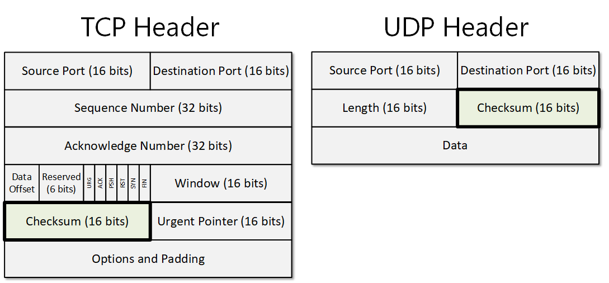

TCP/IP Network Layer – Layer 3
Layer 3 defines the details of how a network infrastructure should be created so that the network can deliver data to all computers in the network. OSI PDU: Packet
- Most commonly used Network Layer protocol: IP
- Internet Protocol (IP) is the most important feature that consists of routing and logical addressing, these standards and services are needed for a computer network. IP will define that each host computer will consist of having a unique IP Address.
IP defines the process of routing in order to forward packets of data to be delivered to the correct destination address.
  - Internet Protocol and the U.S Postal Service
L3‘s IP protocol can be compared to the U.S Postal Services.
- A Letter that was written in NY (PC-A) and another for CA (PC-B) will be put in the same mailbox in order for the postal service to deliver both letters. The postal service (Router) would decide where to send each letter so that it can be delivered correctly. There are different routes for the letter to be sent to NY compared to CA. The postal service (Router) must be able to receive and forward letters and make good decisions about where to send each letter to the destination.
- The person sending a letter (L5 & L4) will allow the postal service (Router) to end up to their destination. In order for a message to be sent, these upper layers would request the lower layers below them (L3, L2, & L1) to deliver the message to their correct destinations.

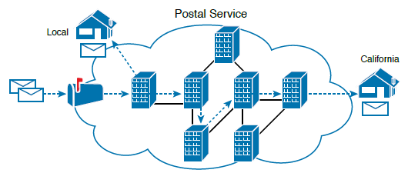
Figure 4: Postal service forwarding (Routing) letters

  - IP Addressing Basics
Each device that uses TCP/IP will need a unique address to be identified within the network. IP would also be able to define how to group addresses together, similar to the postal system using ZIP Codes.

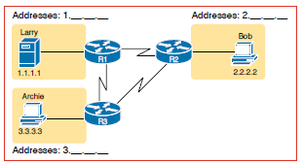
Figure 5: Simple TCP/IP Network: Three Routers with IP Addresses Grouped

  - Explanation of Figure 5
Larry, Bob, and Archie are grouped into their own IP network. Each of the host-devices they use are assigned a unique IP address in order to be identified on the network. This style of number is called the dotted-decimal notation (DDN)
- Larry: Grouped under Network 1.___ .___ .___; Assigned to IP Address 1.1.1.1
- Bob: Grouped under Network 2.___ .___ .___; Assigned to IP Address 2.2.2.2
- Archie: Grouped under Network 3.___ .___ .___; Assigned to IP Address 3.3.3.3
The icon labeled R1, R2, and R3 represent IP routers. The wire between represents links or the medium used for an Ethernet Connection.
Routers are networking devices that connect the parts of the TCP/IP network together for the purpose of routing (forwarding) IP packets to the correct destination.
Routers receive IP packets on various physical interfaces, they can make decisions based on the IP address included with the packet, and then physically forward the packet out some other network interface.

  - IP Routing Basics
L3 uses the IP protocol to provide a service of forwarding IP packets to nearby devices. Any device with an IP address can connect to the TCP/IP network and send packets.
- Routing is the process of forwarding the IP packet once a decision has been made.
- IP Packet is an IP header followed by the encapsulated data after the IP header, this doesn’t include headers or trailers for layers below L3
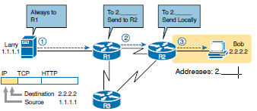
Figure 6: Basic Routing Example
  - Explanation of Figure 6
- Larry’s server is ready to send an IP Packet to the nearby router; R1. Larry will attach an IP header followed by the TCP and HTTP header but will now contain his source IP address (1.1.1.1) and Bob’s destination IP address (2.2.2.2).
The router is expected to know how to forward the IP Packet. Larry’s IP process will choose to send the packet to another router on the LAN. Larry’s server doesn’t need to know any other details regarding the topology or the other routers in the network.
- R1 received the IP packet from Larry which contained his source and destination IP address. R1’s IP process will decide on where to forward the IP packet to the nearby routers; R2 or R3.
R1 will review the destination address (2.2.2.2) received from Larry. R1 compares that address to its known IP routes and will choose to forward the packet to R2 instead of R3.
- Router R2 repeats the same kind of logic used by Router R1. R2’s IP process will compare the packet’s destination IP address (2.2.2.2) to R2’s known IP routes and make a choice to forward the packet to the right, on to Bob.
R1 will review the destination address (2.2.2.2) received from Larry. R1 compares that address to its known IP routes and will choose to forward the packet to R2 instead of R3.

TCP/IP Data-Link and Physical Layer – Layer 2 & Layer 1
The TCP/IP model’s L2 and L1 will define the protocols and hardware required to deliver data across some physical network. OSI PDU for Layer 2: Frame
The Data-Link Layer provides services to the layer above it, L3. When an end device’s IP process chooses to send an IP packet to another end device, that end device will use the link-layer details to send that packet to next host or router.
The Physical Layer defines cabling and energy (electrical signals) that flow over the cables.
- Both data-link and physical layers to include a large number of protocols and standards.
- The Link-layer will include all variations of Ethernet protocols and Wireless LAN protocols
TCP/IP L1 & L2 include two distinct functions:
  - Function related to the physical transmission of data
  - Function related to the protocols and rules that control the use of physical media.
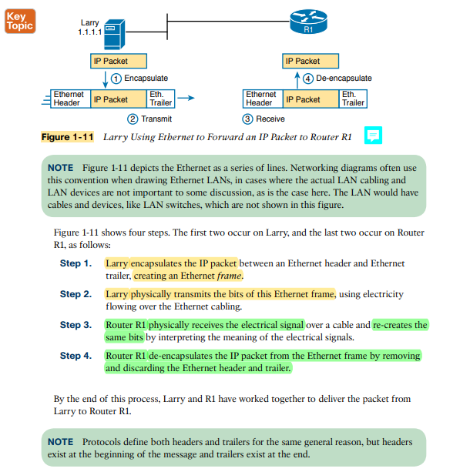
Figure 7: Four steps for the Link Layer. Larry is using Ethernet to Forward an IP Packet to R1.

Data Encapsulation Terminology
When data is sent over the network, each layer would add their own header to the data supplied by the layer above it.
- Encapsulation refers to the process of putting headers and sometimes trailers around data. Each layer is basically putting their own header on top of one another.

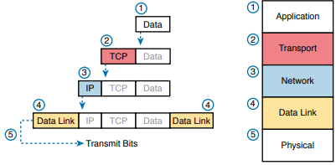
Figure 8: Five Steps of Data Encapsulation for TCP/IP Model
  - Explanation of Figure 8
The encapsulation process by which a TCP/IP host sends data can be viewed as a five-step process.
- Create and encapsulate L5 data, Application Layer, with any required application layer headers. The HTTP OK message can be returned in an HTTP header, followed by part of the contents of a web page.
- Encapsulate the data supplied by L5 inside the L4 TCP header, Transport Layer. For end-user applications, a TCP or UDP header is typically used.
- Encapsulate the data supplied by L4 inside the L3 IP header, Network Layer. IP defines the IP address that uniquely identifies each computer
- Encapsulate the data supplied by L3 inside the L2 header and trailer, Data-Link Layer. This layer uses both a header and a trailer.
- Transmit the bits using L1 medium, Physical Layer. The physical layer encodes a signal onto the medium to transmit the frame.
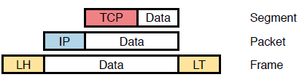
Figure 9: Terminology used to refer to different TCP/IP Layers. L2; Frame, L3; Packet, L4: Segment (F.P.S)

OSI Networking Model and Terminology
OSI Networking Model was the model everyone used BEFORE TCP/IP. TCP/IP is on every computer in the world now, OSI no longer exists as a networking model that can be used.
We only reference OSI for the use of their terminology. Many vendors and protocol documents use the terminology from the OSI model; it remains today.
- OSI model has many similarities to the TCP/IP model. It has layers and each layer would define a set of typical networking functions
- Just like for TCP/IP, the OSI committees didn’t create new protocols or standards, but instead referenced other protocols that were already defined.S
  - IEEE defines Ethernet standards, so the OSI committee just referred to the IEEE Ethernet standards for the OSI model just like how TCP/IP creators did the same thing.
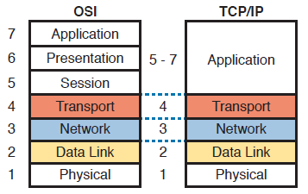
Figure 10: OSI Model compared to the TCP/IP Model

Like TCP/IP, each OSI layer asks for services from the next lower layer. To provide services, each layer will use headers and possibly trailers. The lower layer will encapsulate the higher layer’s data behind a header.
- OSI uses the term protocol data units (PDU’s). A PDU would represent the bits that include the headers and trailers from that layer, as well as the encapsulated data.

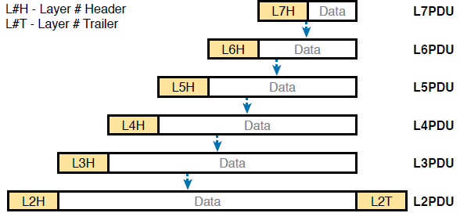
Figure 11: OSI Encapsulation and PDU’s for each layer.

